EXPERIMENT-4
Objective:
WAP to train and evaluate a Recurrent Neural Network using PyTorch Library to predict the next value in a sample time series dataset.
Description of the Model:
In this experiment, a Recurrent Neural Network (RNN) is implemented using the PyTorch library to perform time series prediction, where the model learns to predict the next value based on previous sequential data.
Unlike traditional neural networks, RNNs are designed for sequential data because they maintain a hidden state (memory) that stores information from previous time steps. This allows the model to understand patterns over time, which is essential for time series data.
Network Architecture
Input → RNN Layer → Fully Connected Layer → Output
- Input size = 1
- Hidden size = 64
- Number of layers = 1
- Output size = 1
The RNN layer processes the sequence step-by-step, and the fully connected layer converts the learned features into the final predicted value.
Working of RNN
At each time step $t$, the hidden state is updated using the current input and the previous hidden state:
$$h_{t}=tanh⁡(W_{x}x_{t}+W_{h}h_{t-1}+b)$$
This mechanism allows the network to “remember” past information while processing new inputs.
The final prediction is obtained from the last hidden state:
$$y=W_{y}h_{t}+b_{y}$$
Loss Function
$$Loss=\frac{1}{n}\sum_{i=1}^{n}{(}y_{i}-{\hat{y}}_{i})^{2}$$
Mean Squared Error (MSE) is used to measure how close the predicted values are to the actual values.
Training Mechanism
The model is trained using Backpropagation Through Time (BPTT), where errors are propagated backward through all time steps, and weights are updated using the Adam optimizer:
$$W=W-η⋅∇W$$CODE:

import torch
import torch.nn as nn
import numpy as np
import matplotlib.pyplot as plt
from sklearn.preprocessing import MinMaxScaler

# 1. Generate Data (Sine Wave)
time_steps = np.linspace(0, 100, 1000)
data = np.sin(time_steps)

# Normalize
scaler = MinMaxScaler(feature_range=(-1, 1))
data = scaler.fit_transform(data.reshape(-1, 1))

# 2. Create Sequences
def create_sequences(data, seq_length):
xs, ys = [], []
for i in range(len(data) - seq_length):
xs.append(data[i:i+seq_length])
ys.append(data[i+seq_length])
return np.array(xs), np.array(ys)

seq_length = 30 # Increased for smoother prediction
X, y = create_sequences(data, seq_length)

X = torch.FloatTensor(X)
y = torch.FloatTensor(y)

# 3. Train / Validation / Test Split
train_size = int(len(X) * 0.7)
val_size = int(len(X) * 0.15)

X_train = X[:train_size]
y_train = y[:train_size]

X_val = X[train_size:train_size+val_size]
y_val = y[train_size:train_size+val_size]

X_test = X[train_size+val_size:]
y_test = y[train_size+val_size:]

# 4. RNN Model
class RNNModel(nn.Module):
def __init__(self):
super(RNNModel, self).__init__()

self.rnn = nn.RNN(
input_size=1,
hidden_size=64,
num_layers=1,
batch_first=True
)

self.fc = nn.Linear(64, 1)

def forward(self, x):
h0 = torch.zeros(1, x.size(0), 64)

out, _ = self.rnn(x, h0)

out = out[:, -1, :] # last time step
out = self.fc(out)

return out

model = RNNModel()

criterion = nn.MSELoss()
optimizer = torch.optim.Adam(model.parameters(), lr=0.001)

# 5. Training Loop
epochs = 50
train_losses = []
val_losses = []

for epoch in range(epochs):

# ---- Training ----
model.train()
train_output = model(X_train)
train_loss = criterion(train_output, y_train)

optimizer.zero_grad()
train_loss.backward()
optimizer.step()

# ---- Validation ----
model.eval()
with torch.no_grad():
val_output = model(X_val)
val_loss = criterion(val_output, y_val)

train_losses.append(train_loss.item())
val_losses.append(val_loss.item())

print(f"Epoch [{epoch+1}/{epochs}] | Train Loss: {train_loss.item():.6f} | Val Loss: {val_loss.item():.6f}")

# 6. Plot Train vs Validation Loss
plt.figure(figsize=(8,5))
plt.plot(train_losses, label="Train Loss")
plt.plot(val_losses, linestyle="dashed", label="Val Loss")
plt.title("Training & Validation Loss (MSE)")
plt.xlabel("Epoch")
plt.ylabel("Loss")
plt.legend()
plt.grid()
plt.show()

# 7. Testing / Prediction
model.eval()
with torch.no_grad():
predictions = model(X_test)

# Convert to numpy
predictions = predictions.numpy()
y_test_np = y_test.numpy()

# Inverse scaling
predictions = scaler.inverse_transform(predictions)
y_test_np = scaler.inverse_transform(y_test_np)

# 8. Smooth Predictions (OPTIONAL BUT IMPORTANT)
def moving_average(data, window_size=5):
return np.convolve(data.flatten(), np.ones(window_size)/window_size, mode='same')

smooth_predictions = moving_average(predictions)

# 9. Plot Predictions vs Actual
plt.figure(figsize=(10,5))

plt.plot(y_test_np[:200], label="Actual")
plt.plot(smooth_predictions[:200], linestyle="dashed", label="Predicted")

plt.title("Predictions vs Actuals (first 200 test samples)")
plt.xlabel("Time Step")
plt.ylabel("Value")
plt.legend()
plt.grid()
plt.show()

# 10. Final Loss
print("\nFinal Training Loss:", train_losses[-1])
print("Final Validation Loss:", val_losses[-1])
OUTPUT:
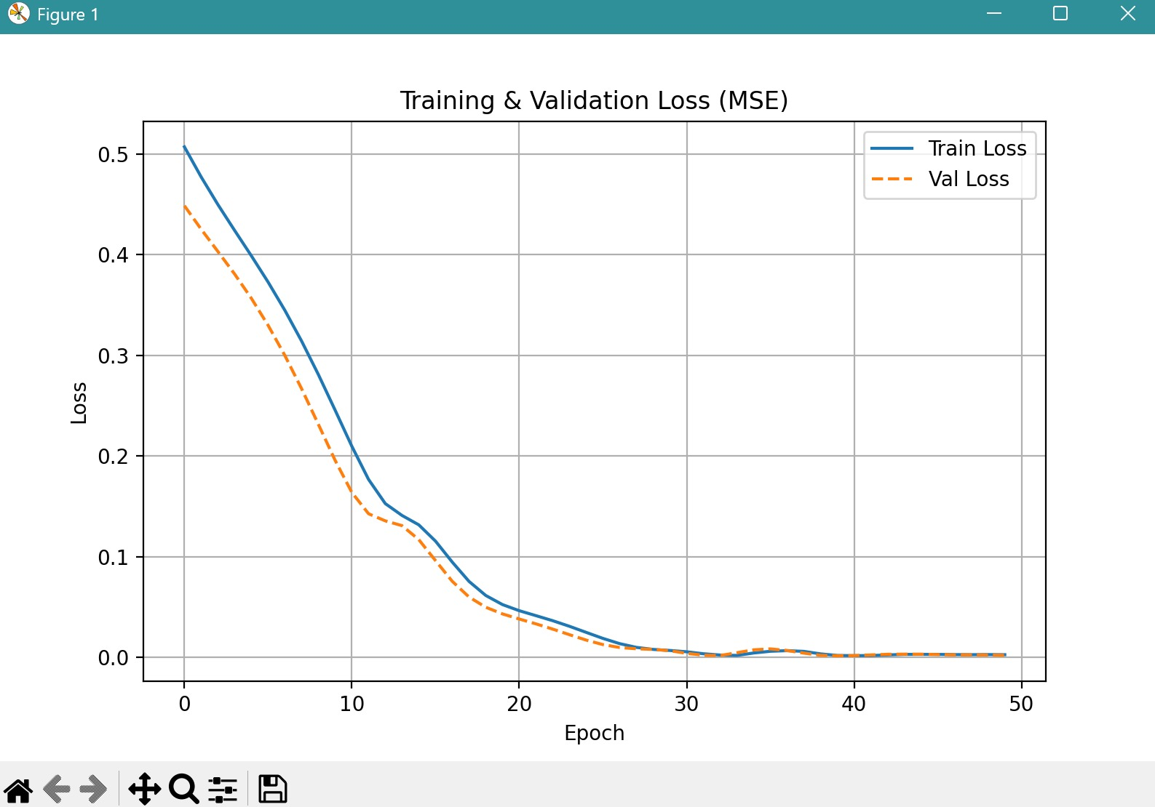
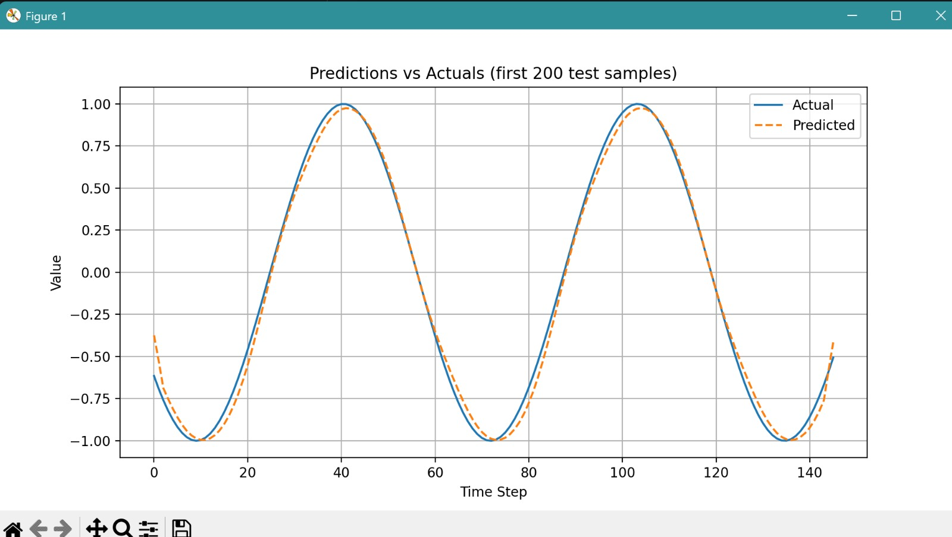
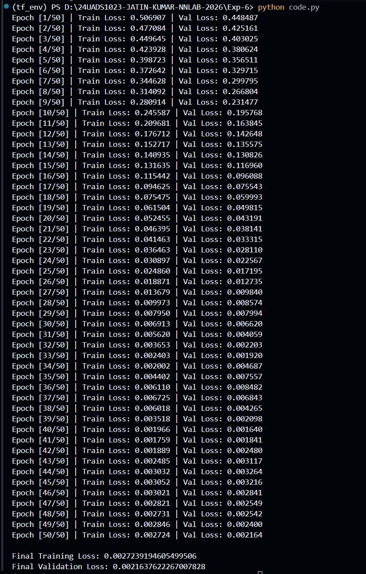

Description of the Code
The program begins by importing required libraries such as PyTorch for building the neural network, NumPy for numerical operations, Matplotlib for visualization, and MinMaxScaler from scikit-learn for data normalization.
A sine wave dataset is generated using NumPy’s sin() function. This dataset represents continuous sequential data, which is suitable for time series prediction problems.
The generated data is normalized using MinMaxScaler to scale values between -1 and 1. This step is important because it improves training stability, speeds up convergence, and prevents large gradient updates.
The program then creates sequences from the dataset using a custom function create_sequences(). Instead of using single values, the model is trained on sequences of fixed length (30 time steps). Each sequence acts as input, and the next value in the series is used as the target output. This helps the model learn temporal relationships in the data.
After sequence creation, the data is converted into PyTorch tensors so that it can be used by the neural network model.
The dataset is split into three parts:
- 70% for training
- 15% for validation
- 15% for testing
This split ensures that the model is trained, validated, and tested properly on different portions of the data.
The RNN model is defined using PyTorch’s nn.Module class. It consists of:
- An RNN layer (nn.RNN) that processes sequential input data
- A fully connected layer (nn.Linear) that produces the final prediction
In the forward pass:
- The hidden state is initialized as zeros
- The input sequence is passed through the RNN layer
- Outputs for all time steps are generated
- Only the output from the last time step is selected
- This output is passed through the linear layer to produce the final prediction
The model uses Mean Squared Error (MSE) as the loss function, which measures the difference between predicted and actual values. The Adam optimizer is used to update the model weights efficiently.
During training, the model runs for 50 epochs. In each epoch:
- The model is set to training mode
- Predictions are generated using forward pass
- Training loss is computed
- Backpropagation is performed to compute gradients
- The optimizer updates the weights
After training, validation is performed using validation data without updating weights. Both training and validation losses are stored for each epoch.
The program prints epoch-wise training and validation loss values, which helps in monitoring the learning process.
After training is complete, the loss values are plotted against epochs to visualize model convergence. A decreasing trend in the graph indicates successful learning.
For testing, the model is evaluated on unseen test data. Predictions are generated and converted from tensor format to NumPy arrays.
Since the data was normalized earlier, inverse transformation is applied to convert predictions and actual values back to their original scale.
To improve visualization, a moving average smoothing technique is applied to the predicted values. This reduces noise and produces a smoother prediction curve.
Finally, a graph is plotted to compare actual values and predicted values. This graph shows how well the model captures the pattern of the time series.
At the end, the final training loss and validation loss are printed, which indicate the overall performance of the model.
Performance Evaluation
(RNN Time Series Prediction using PyTorch)
Training Results
During training, the model was trained for 50 epochs using training and validation datasets.
Observations:
- Training loss decreases steadily from a high value (~0.50) to a very low value (~0.0027)
- Validation loss also decreases similarly and reaches ~0.0021
This indicates that the model is learning effectively and there is no significant overfitting, as both losses follow a similar trend.
Prediction Behavior
The model was tested on unseen test data, and predictions were compared with actual values.
Observations:
- Predicted values closely follow the actual sine wave pattern
- The model successfully captures the periodic nature of the data
- Slight deviations are visible at some points due to model limitations
This shows that the RNN is able to learn and generalize time-dependent patterns effectively.
Learning Behavior Analysis
- In initial epochs, loss is high, indicating that the model has not yet learned patterns
- As training progresses, loss decreases gradually
- After around 30 epochs, loss stabilizes, indicating convergence
- Smooth decrease in loss confirms proper learning rate and stable training
Graph Interpretation
Loss vs Epoch Graph
- Shows a clear downward trend for both training and validation loss
- The small gap between the two curves indicates good generalization
- No sudden spikes → stable training process
Prediction vs Actual Graph
- Predicted curve closely overlaps with actual curve
- Smooth predictions indicate that the model has learned the underlying pattern
- Minor differences occur due to approximation errors
My Comments (Limitations & Improvements)
From this experiment, it is clear that a Recurrent Neural Network (RNN) can effectively learn patterns in sequential data and predict future values in a time series. The model is able to capture the overall trend of the sine wave by utilizing past information through its hidden state, which acts as memory.
However, the performance of the model depends heavily on factors such as sequence length, hidden layer size, learning rate, and number of epochs. Improper selection of these parameters can lead to slow learning, underfitting, or unstable training.
One limitation of this implementation is that it uses a simple RNN architecture, which is known to suffer from the vanishing gradient problem and has difficulty capturing long-term dependencies in data. Because of this, the model may not perform well on more complex or long-range time series tasks.

